SHROPSHIRE PLAYING FIELDS ASSOCIATION

Affiliated to the National Playing Fields
Association launched by Lloyd George -1925

SPFA

`The right to play is a child`s first claim on the community`.

`PLAY THROUGH SPORT’

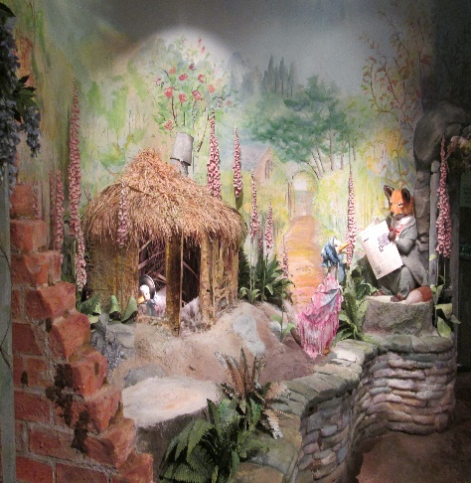

REPORT AND ACCOUNTS

APRIL 2024 – MARCH 2025

Registered Charity No 522594
SHROPSHIRE PLAYING FIELDS ASSOCIATION

Shropshire Playing Fields Association provides advice and support to promote good practice across the outdoor sport, play, physical activity, recreation, and leisure industry.

We have three key objectives these are to:

- Protect against the loss of outdoor sport, play and informal recreation facilities.

- Support the enhancement of existing outdoor facilities through improving their quality, accessibility, and management.

- Support the provision of new facilities that are fit for purpose, to meet the demand for participation now and in the future.

PLAY
Play is an innate mechanism with no fixed boundaries that is accessible by everyone.
Play is not a separate activity, but an integral part of leisure, work, sport, and recreation.
Play is all about the quality of the experience rather than the activity itself.
Importantly play has formed the basis for all human cultures and civilisations so offers considerable opportunities to promote social cohesion across diverse communities.

Lloyd George in launching the National Playing Fields Association in 1925 attached the highest priority to play. The right to play is a child`s first claim on the community. Play is nature`s training for life. No community can infringe that right without doing deep and enduring harm to the minds and bodies of its citizens.

UN Convention on the Rights of the Child - "Mankind owes to the child the best it has to give”
- Eglantyne Jebb, Shropshire born and founder of Save the Children.

The UN Convention on the Rights of the child is an international treaty that sets out globally accepted rights for children. It outlines the benefits and protection for children.
That every child has the right to rest and leisure, to engage in play and recreational activities appropriate to the age of the child and to participate freely in cultural life and the arts.

It is agreed that member governments shall respect and promote the right of the child to participate fully in cultural and artistic life and shall encourage the provision of appropriate and equal opportunities for cultural, artistic, recreational and leisure.

We remember and look forward.

Fields in Trust is a charity incorporated by Royal Charter and has since it was established in 1925, had support from our Royal Patron and Presidents.

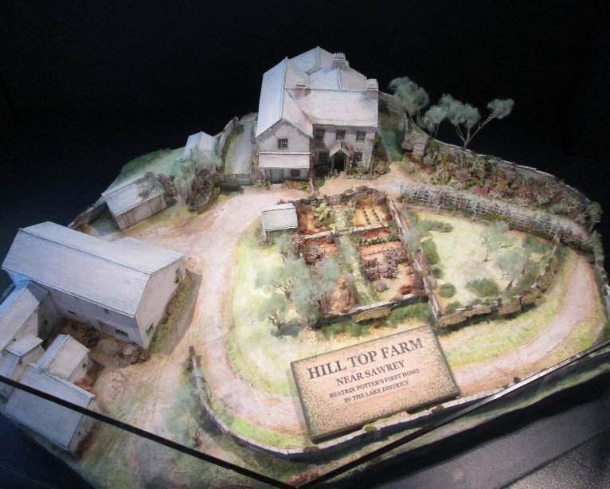
NPFA was founded by HRH The Duke of York, later HM King George VI, in 1925 as the National Playing Fields Association. In 1932 their first Patron, HM King George V granted a Royal Charter.
Since 1925 the National Playing Fields Association has worked to ensure the survival of parks and green spaces by securing legal protections, supporting landowners and lobbying policymakers for change.
Today, the relevance of the Fields in Trust Standards in Planning National planning policy in England recognises the importance of providing accessible, high quality open spaces to achieve sustainable development.
The FIT Standards are recognised across the UK as a common approach for delivering accessible, high quality open space, sport and play provision in line with national planning policy.
Using the FIT Standards from the beginning of the planning process embeds a focus on achieving better design outcomes from the start, and by incorporating benchmarks on quantity and accessibility.
Using Fields in Trust’s framework of 6 themes can help drive a broader agenda of quality and functionality. working with developers, planners, neighbourhood planning groups and town and parish councils to assess and analyse current provision levels, using their Green Space Index and identify where this does not currently meet the FIT Standards.

Chairman’s Report 2025

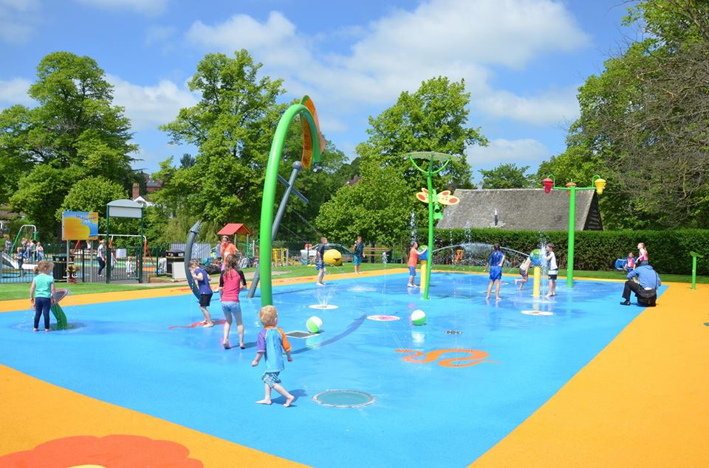

I would like to start by thanking all of you for giving of your time generously to protect and enhance the recreational and open space opportunities for our communities. It goes without saying that without your time and efforts our local residents would have reduced sport, recreational and play facilities.

This is my third Chairman’s report in what promises to be an interesting centenary year for the National Playing Fields Association founded in 1925.

Whilst recognising the first Playing Field Association in Shropshire did not start until 1928, I believe it is important that as an association we recognise the achievements of the National Body and agree on a suitable way to mark the 100 years of many volunteers across the United Kingdom for this purpose.

The actual birthday of the association is July 8th so it would seem appropriate to mark the occasion on that day or soon after this date, any suggestions of how best we might do this would be very welcome, so please forward to our Secretary as soon as possible.

On a personal note I would just like to apologise for missing one or two meetings this year due mainly to unforeseen health issues that I am now thankfully well on the way to resolving, a special thank you to Ray for stepping into my Chairmans role when needed.

Finally, I take this opportunity to seek help, from anyone who is willing and able to give their time to help with any fund raising ideas or activities to help promote the work of the playing field association across the Shropshire, Telford and Wrekin area
Ian Brett
Chairman SPFA

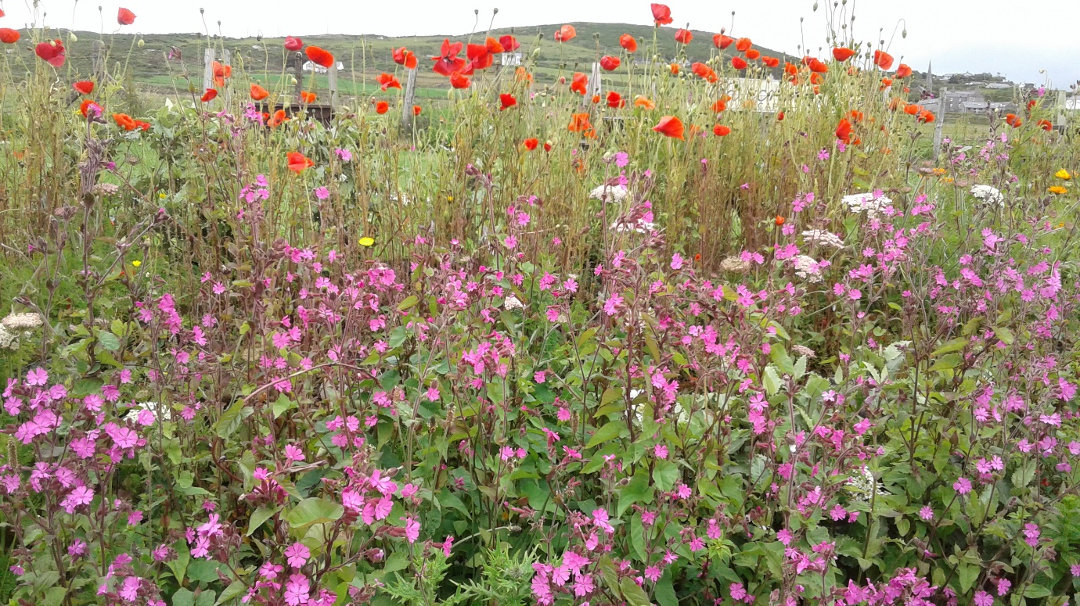

Secretary Report 2024 – 2025

I start my annual report by thanking all of you that have continued to support the Shropshire Playing Fields Association as we continue to keep pace with changing trends and times across the County of Shropshire, Telford, and Wrekin to do with outdoor physical activity, play, sport, recreation, and leisure facilities.

Trustees
James Lavery, David Beechey and Tony Durnell have all kindly agreed to continue as trustees of the Shropshire Playing Fields Association keeping our number at three. Your secretary is mindful that long term we need to grow our number of trustees, whilst seeking to develop a more diverse profile across our ranks.

Centenary challenge 2025-2028
The National Playing Fields Association (NPFA) was founded on 8 July 1925. It is a registered charity and received a royal charter in 1932.

Its aims were to secure adequate playing fields for the present and future needs of all sections of society, to secure proper playgroups for the children, to save existing sports grounds and the open spaces that remain in urban areas, to co-operate with all local authorities and others who are striving to secure these objectives, and to act as a pressure group to focus local opinion.

In Shropshire the first records of a playing field association was in Oswestry in 1928, taking account of the need of our current Shropshire Playing Field Association it is the intention of your Secretary to celebrate these important landmarks by promoting the role of the playing field association across Shropshire recognising the need for an association both then and now going forward.

During the next three year period, commencing July 8th 2025 until July 8th 2028 your secretary has set SPFA the challenge of trying to recruit and retain 100 new volunteer members to ensure our future.

A second challenge if successful with the first, will be to launch as many as possible local playing field associations around the Telford, Wrekin and Shropshire area, so that our coverage on the ground is widespread allowing us to be more effective in our pursuit of these objectives.

It is my intention to stand down as Secretary of the main Shropshire Playing Fields Association at an appropriate time during this next three year period, so anyone wishing to take on the role or anyone who knows someone suitable to take on the role should contact myself directly to discuss a possible handover.

Shropshire Playing Pitch and Outdoor Sports Strategy
The Shropshire Playing Pitch and Outdoor Sports Strategy review report was completed and agreed by Shropshire Council in March 2024.

Shropshire Playing Fields Association have been a part of the working group that meets regularly to review and up-date the report.

SPFA continue to voice their concerns relating to a lack of robust evidence being put forward with regard to the important ‘access and availability’ element when considering each sports facility being researched across the county of Shropshire, we also are concerned regard the limited scope of the strategy which only takes into consideration seven key sports, including football, rugby, cricket, hockey, netball, tennis and bowls.

We continue to lobby Shropshire Council and Telford and Wrekin Council along with local town and parish councils to provide robust and up-to date needs assessment for their open spaces, sport and recreation facilities as required in order to adhere to paragraph 98 and 99 of the National Planning Policy Framework.

Our next meet up is on June 3rd 2025 at Lilleshalll N.S.C

Planning gains
With so many residential developments occurring in the county a great deal of money is required to be spent from these developments either through commuted 106 agreements or community infrastructure levy funding.
The evidence so far reflects that too little of this infrastructure money is being spent on the creation of new play areas, sports pitches, urban or countryside parks, that could be used to meet the needs of the new residents.
It is important that as an organisation we continue to help identify where these funds should best be spent by working with local communities, sport clubs and associations, town and parish councils through their local development plans, place plans, neighbourhood plans, community led plans, sport plans.
In addition to identifying where money should be allocated towards providing new facilities there is also a need to monitor that conditions, forming planning applications are being adhered to in full, and that financial planning gains are being distributed to appropriate and relevant causes.

Sport England statutory planning body
As part of the national planning and infrastructure bill the government has said it wants to “speed up the delivery of new homes and critical infrastructure” by removing the powers of some of the statutory consultees on planning decisions.
These include large organisations such as the Environment Agency and Natural England but the minister for housing and planning, Matthew Pennycook, recently announced that the government’s “initial intention is that this will include Sport England, the Theatres Trust and the Gardens Trust”.
Sport England’s chief executive, Tim Hollingsworth, said: “History shows us that without effective action taken to protect playing fields, we will see vital facilities lost, particularly often in those areas that are already least well served. With a child obesity crisis and £7.4bn lost to the economy each year to inactivity, it’s essential we get the balance right.
“Once you lose a playing field or pitch, it’s gone for ever.”
SPFA have always worked closely with Sport England on local planning matters so take this threat seriously as we strive to protect our public open spaces including parks, school pitches and sports pitches from future development
We look forward to another year ahead in our bid to protect, enhance and support the provision of new outdoor open spaces.

David Kilby
Secretary
May 2025

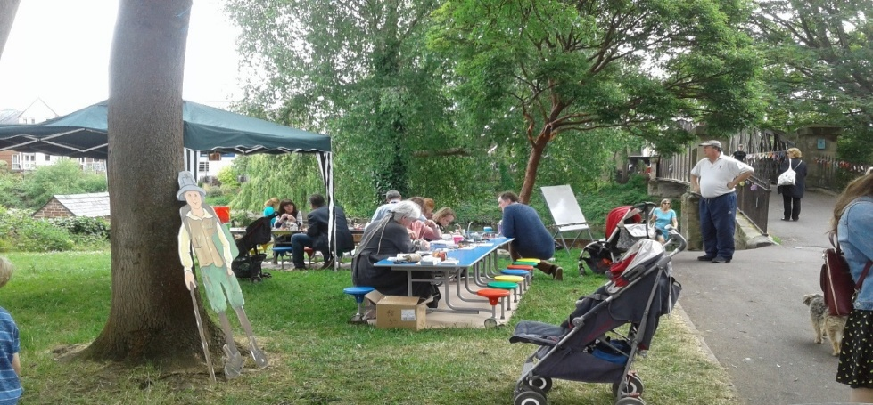

Treasurers Report



Since last year the transfer of the running of the charities accounts has continued to be smooth, with the instalment of online banking and other web services enabling us to have an accurate up to date insight into the finances of the organisation.

We have now moved the majority of our assets into a fixed term bank savings account, which continues to return a significant percentage of interest each year.

The loan to Madeley Cricket Club was repaid promptly on time providing an opportunity for other clubs to take out a loan in the future

The coming year looks set to be a good year for the charity and by having our finances in order we are able to utilise our assets fully and aid the community where necessary.

Further fundraising will move forward at the discretion of our secretary aided by myself where required.

Seb Preston – Treasurer

CHARITY NUMBER 522594

SHROPSHIRE PLAYING FIELDS ASSOCIATION

INDEX TO THE FINANCIAL STATEMENTS

FOR THE YEAR ENDED 31 MARCH 2025

Trustees’ Annual Report 1

Receipts and Payment Accounts 2 – 3

Statement of Assets and Liabilities 4

Notes to the Accounts 5

SHROPSHIRE PLAYING FIELDS ASSOCIATION
FOR THE YEAR ENDED 31 MARCH 2025
ACTIVITIES AND ACHIEVEMENTS DURING THE YEAR
Administration and disbursements of loan funding to approved sports and play projects, sports coaching, and talented youngsters in Shropshire.
Promotion of the value of play for children through the deliverance of workshops.
Verbal and written technical advice to voluntary sector sports clubs, play projects in Shropshire and Town and Parish Councils on related matters.
Quarterly committee meetings.
Attendance at several other agencies with interests and concerns in the above matters, both statutory and in the voluntary sector.

SHROPSHIRE PLAYING FIELDS ASSOCIATION
TRUSTEES’ ANNUAL REPORT
FOR THE YEAR ENDED 31 MARCH 2025
LEGAL AND ADMINISTRATION INFORMATION
Charity Name | Shropshire Playing Fields Association (SPFA)
Registered Charity Number | 522594
For the Financial Year Ending | 31 March 2025
Principal Address | C/o Dyke Yaxley Limited  1 Brassey Road  Old Potts Way  Shrewsbury  SY3 7FA
Trustees | J Lavery
 | T Durnell  D Beechey | Vice Chairman
Name of Body Entitled to
Appoint Trustee | SPFA Council
Governing Document | Constitution Adopted October 1970
Objects of the Charity | To advise and assist in the provision and protection of playing fields and playgrounds. To encourage playing of all games and sports, including financial aid.
Bankers | Lloyds Bank Plc, Pride Hill, Shrewsbury

Shropshire Playing Fields Association
Year End 31st March 2025
Receipts and Payment Account

Receipts | Play Scheme Fund | Restricted General Purpose | Loan Fund | Total | 2024
From Voluntary Sources
Subscriptions, Donations and Affiliation Fees |  | 50.00 |  | 50.00 | 50.00
Interest Received |  | 726.00 |  | 726.00 | 96.00
Gifts |  |  |  |  | 500.00
Total | 0.00 | 1,174.75 | 1,000.00 | 2,174.75 | 646.00

Shropshire Playing Fields Association
Year End 31st March 2025
Receipts and Payment Account

Payments | Play Scheme Fund | Restricted General Purpose | Loan Fund | Total | 2024
Insurance |  | 299.25 |  | 299.25 | 243.08
Subscriptions |  | 50.00 |  | 50.00 | 50.00
Printing, Postage and Stationary |  | 30.00 |  | 30.00 | 5.00
Accountancy |  | 300.00 |  | 300.00 | 300.00
Sub Total | 0.00 | 679.25 | 0.00 | 679.25 | 598.08
Loans Advanced | 0.00 | 0.00 | 0.00 | 0.00 | 0.00
Total | 0.00 | 679.25 | 0.00 | 679.25 | 598.08
Net Cash Flow | 0.00 | 495.50 | 1,000.00 | 1,495.50
Funds at last year end | 9,493.00 | 15,602.76 | -1,000.00 | 24,095.76
Funds at Year End | 9,493.00 | 16,098.26 | 0.00 | 25,591.26

SHROPSHIRE PLAYING FIELDS ASSOCIATION

NOTES TO THE ACCOUNTS

FOR THE YEAR ENDED 31 MARCH 2025

- Accounting Policy
The accounts of the Shropshire Playing Fields Association have been prepared in accordance with Section 42(3) of the Charities Act 1993 as the Charity’s gross recorded income from all sources was £100,000 or less and it is not a Registered Company.

- Play Scheme Fund
This fund was set up using a Grant provided by the Community Fund. The Association was responsible for administering the Grant which covered activities extending over a three-year period which ceased on 31 October 2002. The Community Fund has allowed the Shropshire Playing Fields Association to retain surplus funds from the project on the understanding that it is used for the further support and promotion of children’s play.

- Committed Liability
The Shropshire Playing Fields Association offers loans and as at 31 March 2025, there were no loans outstanding. The net loan funds available to draw as at 31 March 2025 is stated as (£7,889) and the total assets of the Association are stated as £25,591.26

- Prepaid expenses
The Shropshire Playing Fields Association have prepaid for the 2025-2026 their public liability fees to the sum of £305.80

MEMBERS AND ASSOCIATES OF SPFA COUNCIL 2025 -2026
Officers
President; Ray Wickson
Chairman Ian Brett
Vice Chairman Tony Durnell
Treasurer Seb Preston
Secretary David Kilby

General Committee
I Brett D Beechey A Turner D Kilby R Wickson J Durnell K Halliday
S Preston J Lavery N Green A Weston D Owen D Howell S Reese
C Healey D Gray M Wilson

Trustees
David Beechey James Lavery Tony Durnell

Local authority
Shropshire, Telford, and Wrekin Council
Shropshire Council representatives; Nat Green.
Telford and Wrekin Council representatives; Carolyn Healey

Shropshire, Telford and Wrekin, Town, and Parish Council Committee Members
SALC Representative Ray Wickson
Shrewsbury Town Council Kate Halliday
Lilleshall, Donnington, and Muxton P.C James Lavery
Albrighton Parish Council David Beechey

Shropshire, Telford and Wrekin Town and Parish Council Members and Associates
Selattyn & Gobowen Parish Council; Madeley Town Council; Hinstock Parish Council; Dorinington with Boscobel Parish Council. Ellesmere Town Council; Sheriffhales Parish Council; St.Georges & Priorslee Parish Council; Newport Town Council; Bayston Hill Parish Council; Ercall Magna Parish Council; Chetwynd Aston &Woodcote Parish Council; Donnington & Muxton Parish Council;

County Sports Associations and Clubs
Shropshire Crown Green Bowls: Dawn Gray Shropshire Cricket Board: Simon Reece
Shropshire Football Association: Andy Weston North Midland Rugby Union: Don Howell Shropshire Tennis: Mark Wilson

Individual Members
Anna Turner, Dave Kilby, Ian Brett, Seb Preston Tony Durnell.

